# **Assignment: Revising Your Prototype**

**My Updated Prototype:**

***Your name:*** K.Balaram Pratap

***1. Your current “How Might We?” question:***

How might we educate or create awareness among people about ill effects caused due to not bothering about their mental and physical health in this busy world?

**2. *Title or name for your process/service:***

“The PREVENTION PRESCRIPTION Process”

**3. *Your Design Challenge:***

First, my local community and then the larger global audience – anyone who can benefit from the interactive awareness sessions on mental and physical health care and also to empower themselves to live healthy lifestyle and avoid chronic work stress.

This process/service is more convenient to those people who spare time for their health when advised by primary care physicians.

**4. A “Problem Statement” that explains what your prototype is intended to solve:**

(50–100 words)

During my research, I learned that not having proper guidance and lack of sparing minimum time to care about their health in their busy schedule has made people to suffer with mental and physical health problems.

People getting busy with their works which constricted them to simply follow doctor’s word’s about any factor related to health problems and maintenance. I found that due to improper guidance people are facing many health problems due to chronic work stress and psychosocial work stresses.

I even found that health care system is with many loopholes and that can be refined for effective health care system.

***5. Your prototype concept: what it is, how it works, and why it is a good idea:***

My process is named as “THE PREVENTION PRESCRIPTION PROCESS”. This idea aimed to teaching and implementing high-value health system administration by collaborative team of patients, clinicians, quality improvement specialists and educators/guiders. My process focused on implementing high-value care in clinical practice process.

***6. Feedback and insights:***

I proposed my idea of bringing change in present health care system to my family members, friends, professors and to my friendly doctor. I got a positive feedback from all of them and even they helped me in spreading up my idea to the next level. They asked me to add still more to the present idea to make it more effective.

Then I thought of building a tool to manage, report and analyze actual system costs and outcomes at many levels, including by individual encounters, department, physicians, diagnosis and procedure. This tool will bring an effective clinical outcomes and create a clear vision to patients about the exact problem they are facing and the medical expensive to the treatment. Then this tool can be initialized in every hospital.

**COLLOBORATIVE APPROCH IN MY PROCESS:**

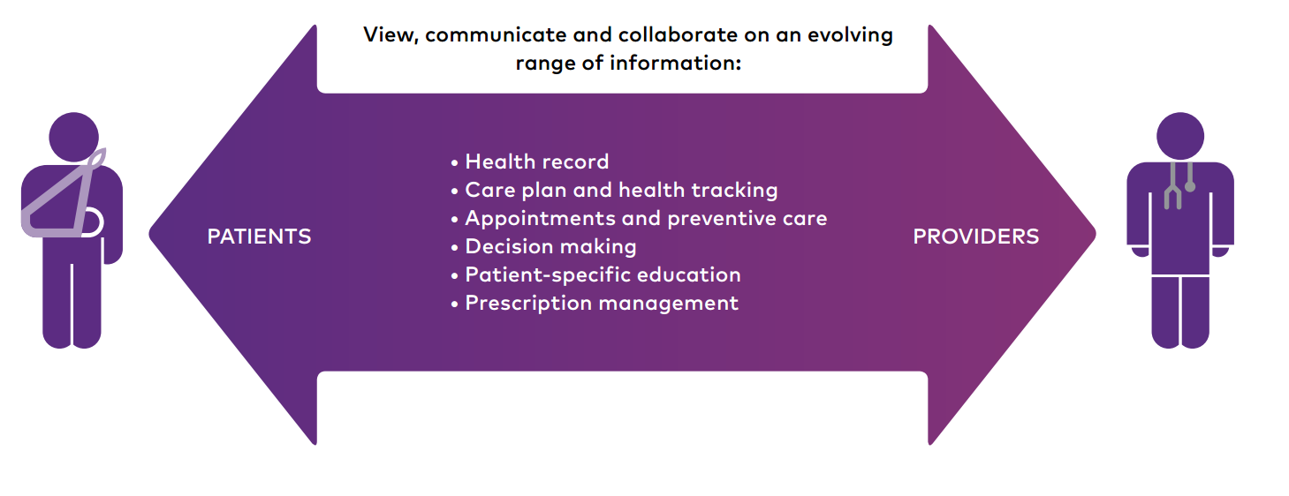

***7. Your revised prototype:***

***Modification/Addition I could do to my service/process that I have been designing in this course to make it more sustainable and contribute to positive social change are:***

* Making this process more prominent by providing this process as an advice by influential doctor’s.
* Making this process common in every hospital, mostly in private hospitals.
* Suggestions/ prescription to interactive awareness session provided by the doctors must be more effective sessions so that it can influence most people to look after/maintain a healthy lifestyle.
* Getting support from local hospitals and health organizations.
* Taking feedbacks from people who experienced the change after using this process and implementing changes according to insights received from them.